**Output of Validation of Mail**

**Case 1- Correct Email and Password**

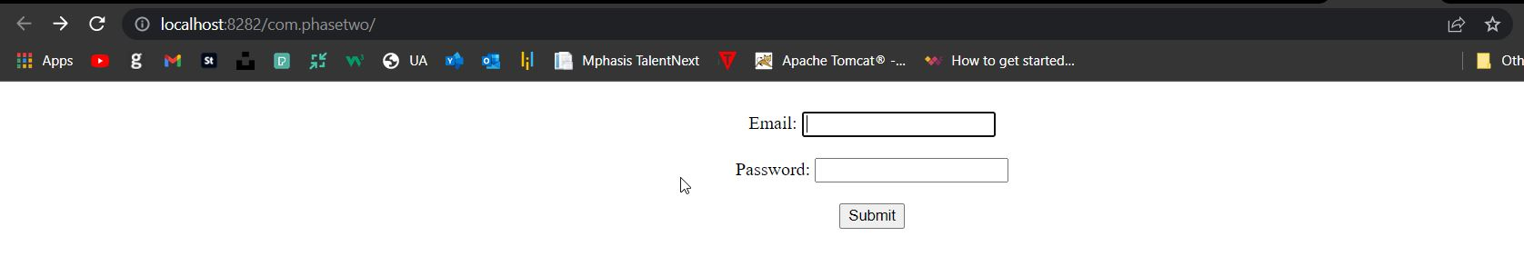

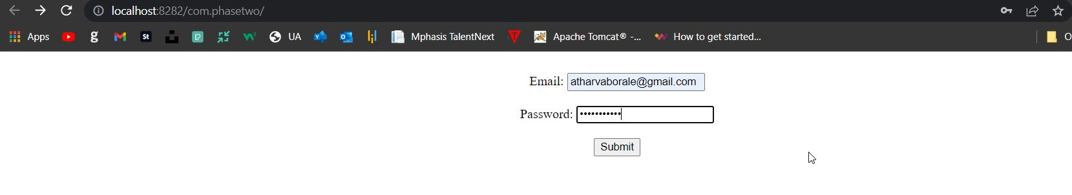

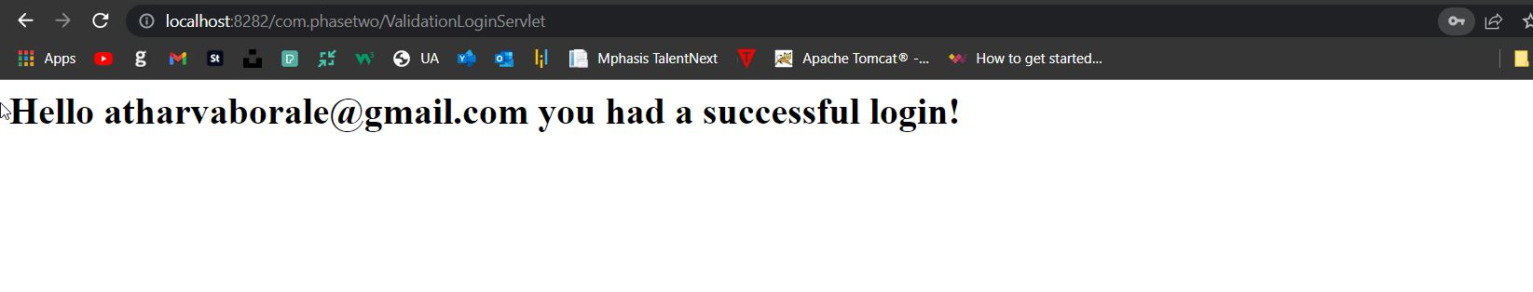

**Case 2- In-correct Email And Password**

